ASSIGNMENT 9

Que 1.Write a query that lists each order number followed by the name of the customer who made the order.
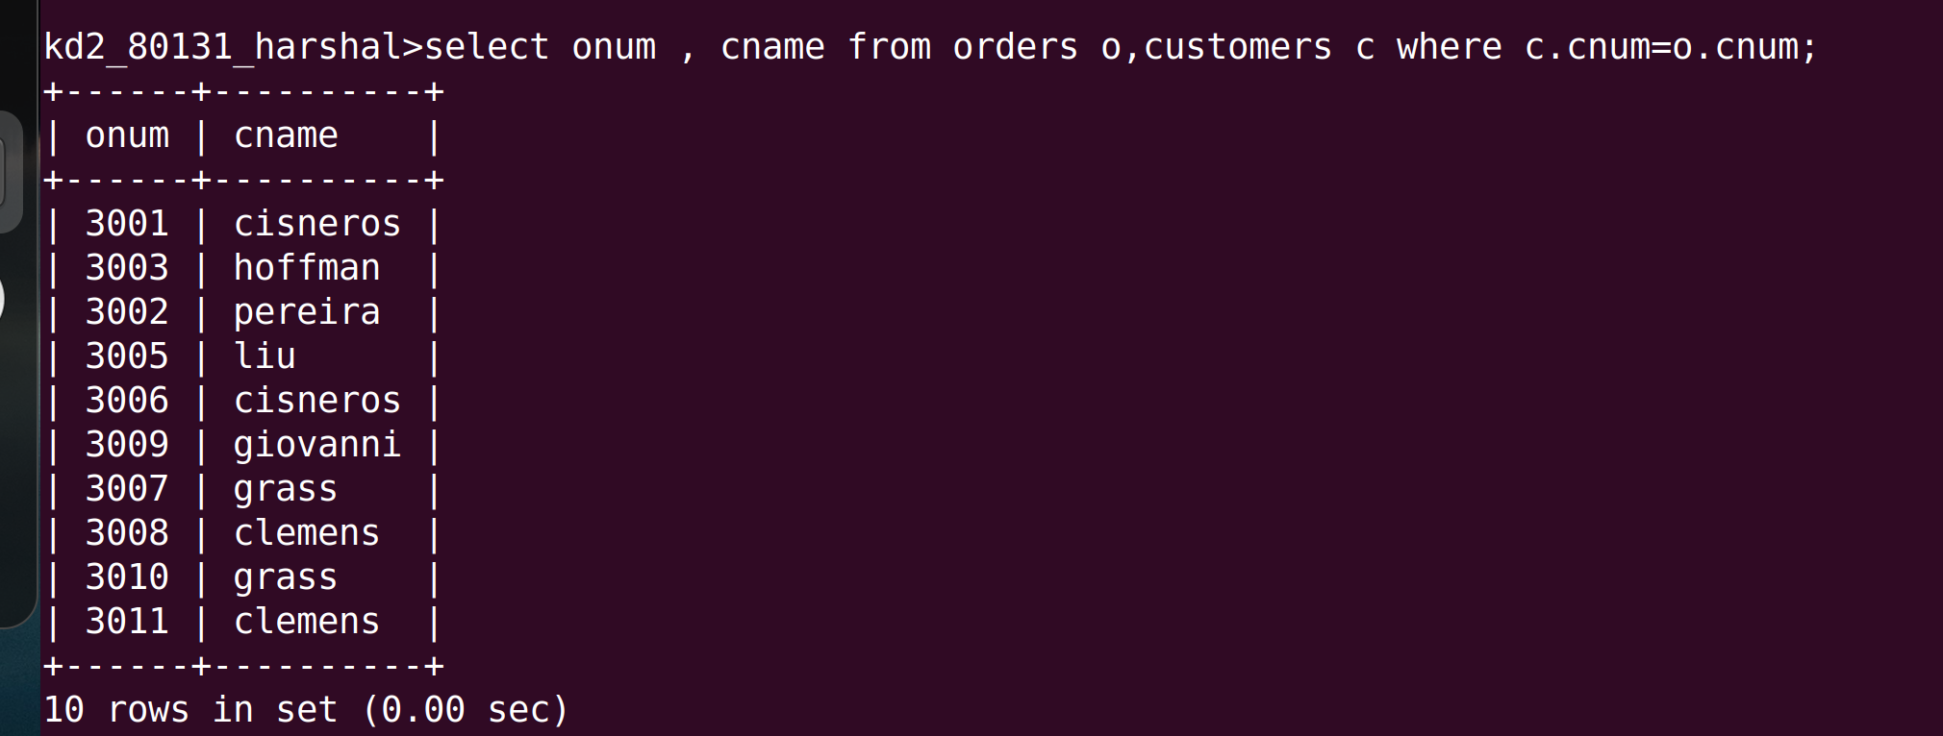
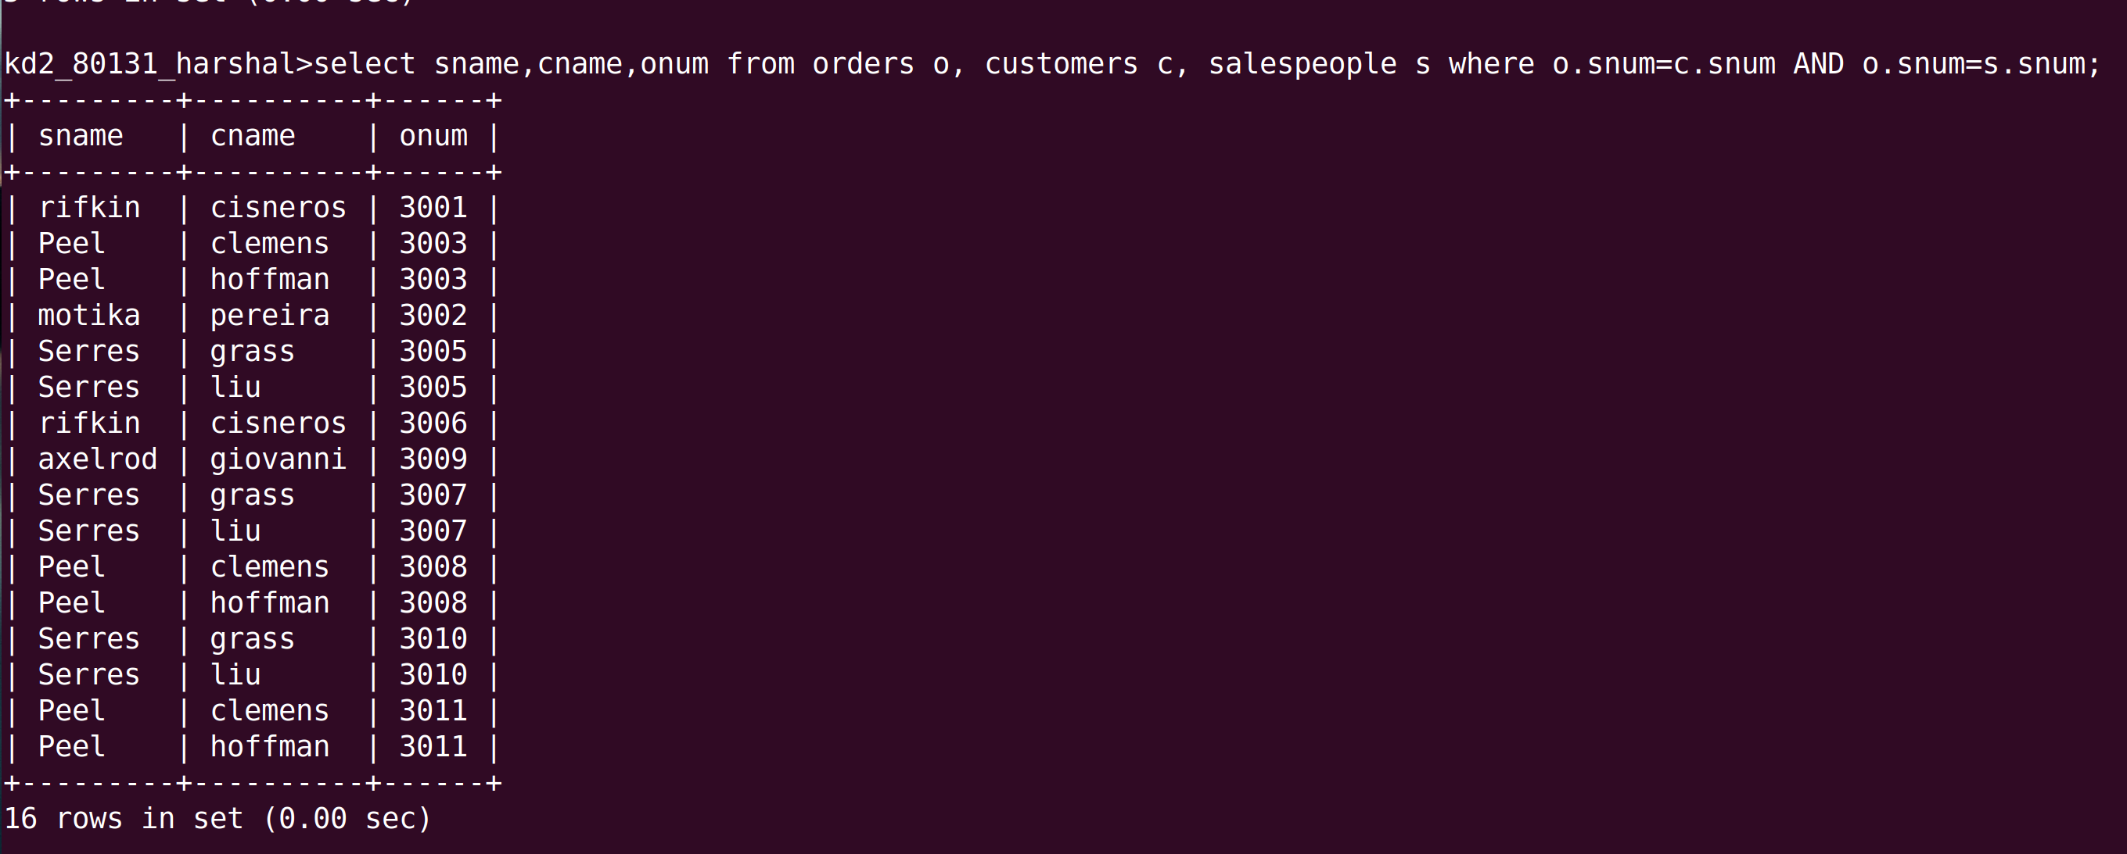
Que 2.Write a Query that gives the names of both the salespeople and the customers for each order along with the order number.

Que 3.Write a Query that produces all customers serviced by salespeople with a commission above 12%. output the customers name,the salesperson name the salespeople rate of commission.
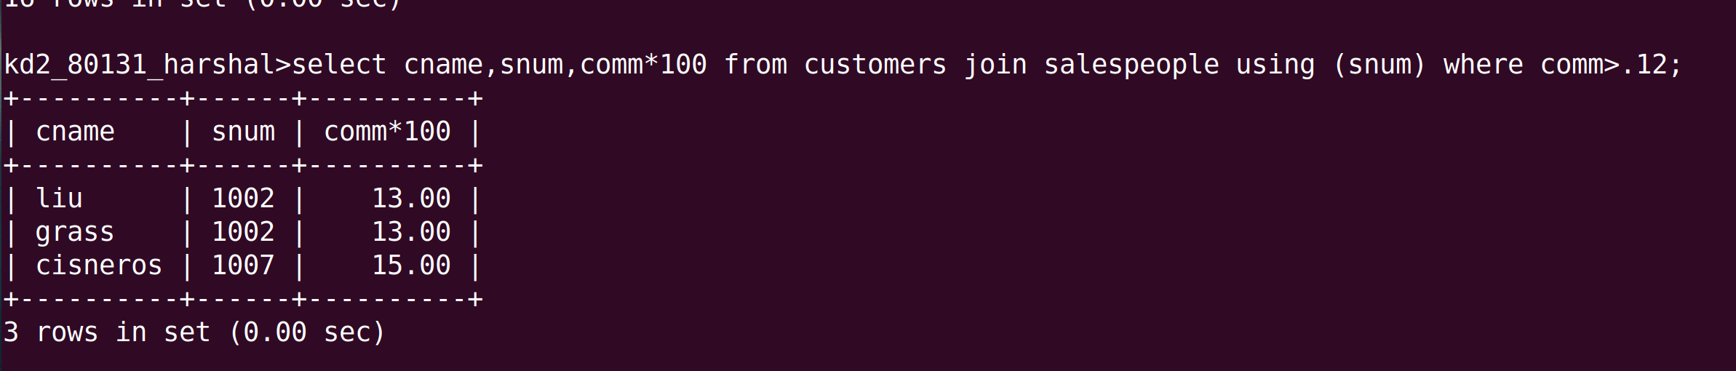
Que 4. Write a query that calculates the amount of the salespeople commission on each order by a customer with a rating above 100.
